**Big Brand Case Studies: How the World's Biggest Names**

**Big Brand CRM Case Studies 2022**

Written by [**Rob Binns**](https://www.expertmarket.co.uk/author/robert-binns)

Updated on **20 April 2021**

***Apple, Amazon, and… your business? Join the ranks of the planet’s biggest brands, and find out how CRM is the secret to their success***

How did a handful of ambitious thinkers take simple ideas and grow them into instantly recognisable brands, and… into **companies worth hundreds of billions of pounds?** Well, they did it by retaining a firm focus on the customer. And they did *that*through the use of **CRM (Customer Relationship Management)**.

**CRM** refers to both:

1. A type of software (such as Maximizer or Salesforce) that helps businesses manage leads, deals, and clients, and craft targeted marketing campaigns.
2. The specific strategies via which a business engages and retains its existing customers.

**Big Brand CRM Case Studies**

With **CRM**, the Tescos and Amazons of this world were not only able to win new customers, clients, and users – they got **lifetime value**out of them. With **targeted marketing campaigns**, these brands hit the right people with the right offers, at *exactly*the right time.

So, what kind of lessons can you take from the best in the business? Is CRM the key with which you can unlock your own company’s potential, and fuel commercial growth on a scale that rivals the big guns? Let’s take a look at**our top 11 CRM case studies from the world’s leading brands**.

Or, if you're just ready to get started with a CRM system yourself, check out our recommended partners below.

**1. Tesco CRM**

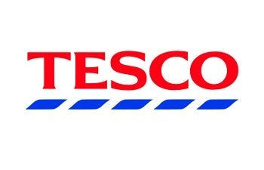

Tesco is a truly global business. It’s one of the [world’s top 10 retailers](https://www.investopedia.com/articles/markets/122415/worlds-top-10-retailers-wmt-cost.asp), with supermarkets across Asia, Europe, and North America. With more than 3,400 stores in the UK alone, you’ll probably know it as your first port of call for a spontaneous pint of milk, or for an indulgent £3 meal deal during your lunch hour. So, what’s the secret to Tesco’s success? Well, it boils down to one main factor: The **Tesco Clubcard**.

**Tesco CRM: Case Study**

The Tesco Clubcard is Tesco’s way of rewarding its most loyal customers. For every pound you spend online or in-store, you’ll get a point. These points, when accumulated, can be traded in for Tesco Clubcard ‘vouchers’ (for instance, 150 points gets you a £1.50 voucher).

A voucher can then be traded in for rewards, such as an afternoon at Cineworld with the kids (a timeless experience), or an evening at [Pizza Express](https://secure.tesco.com/clubcard/pizzaexpress/uk-009864.prd) (enjoy it while you can). Clubcard holders can also collect points at [Tesco fuel](https://www.expertmarket.co.uk/fuel-cards/tesco-fuel-cards) stations, and by filling out feedback surveys online.

What’s in it for Tesco? Returning customers that are invested in the brand, and whose opinion Tesco can leverage to continue improving its growing basket of offerings.

**2. Apple CRM**



This one needs no introduction. Founded by visionary Steve Jobs in 1976, this instantly recognisable brand is the *apple*of many a tech-lover’s eye. [Apple](https://www.expertmarket.co.uk/crm-systems/apple-crm-case-study) has given us the iPad, iPhone, iMac, and Apple TV. But anyone who’s ever used one of its slick, stylish products knows that Apple’s appeal goes far beyond its niftiest handheld devices…

… because it’s how it treats its customers that’s the key to Apple’s success.

**Apple CRM: Case Study**

Let’s take **Apple ID** as an example. If you’ve ever used iTunes (Apple’s online music streaming service), you’ll have an Apple ID – and if you’ve ever used an Apple device, you’ll have had to register it using an Apple ID, too.

These unique IDs synchronise across devices, remember music and film selections, and provide personalised recommendations based on what’s you've been watching or listening to. For the user, it offers convenience. And for Apple, it’s a constantly updating data set, telling the company exactly what its customers like and allowing for effortless, targeted marketing. It’s…. CRM, done well.

**3. Uber CRM**

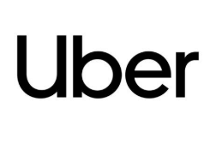

Uber arrived in 2009 to spearhead the ride-sharing revolution, and has quickly become a household name. But, with a huge host of new competitors driving costs down (not to mention [a few other issues](https://www.bbc.co.uk/news/business-50544283)), Uber’s monopoly over its 95 million worldwide monthly users could be under threat. Can Uber hold on? And what can help us understand how successful Uber has been thus far in retaining its enormous customer base?

**Uber CRM: Case Study**

Well, CRM is a good place to start – and for Uber, it’s industry-leading CRM software provider [Salesforce](https://www.expertmarket.co.uk/crm-systems/salesforce-review) that’s powering the ride-sharing giant’s strategy. Salesforce helps Uber extract data from people engaging with its brand on social media. With this system in place, Uber can reply with haste to customer complaints, and track all its interactions with the public from an intuitive dashboard.

And, of course, it runs its own loyalty program. **Uber Rewards**lets you earn points every time you ride or eat with Uber, and redeem them across its increasing range of services. It’s a textbook example of how Uber is incentivising customers to keep relying on its brand, as it [continues to branch out](https://www.telegraph.co.uk/technology/2019/05/24/uber-launches-app-based-electric-jump-bikes-streets-london/).

**4. British Airways CRM**

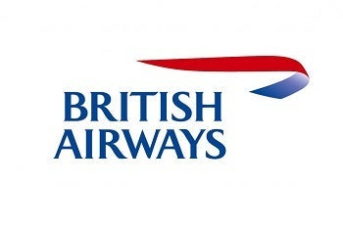

In the hotly contested, heavily consumer-oriented aviation space, you’ve got to get your CRM strategy right. And, clearly, British Airways (BA) does – flying 145,000 people to more than 200 destinations every *day*. So, why do its customers keep coming back? The answer can be summed up in two words… Executive. Club.

**British Airways CRM: Case Study**

The**British Airways Executive Club** is an example of CRM loyalty schemes done right. Free to join and with no ongoing charges, the club allows customers to earn ‘Avios’ points through purchasing flights, hotel stays, holidays, or car rental through BA or its partners. Avios points can then be redeemed for discounts on travel or accommodation with (you guessed it!) BA.

Customers can save their meal and seat preferences, making for a smoother, more seamless re-booking experience. And, as they continue to fly with BA, they’ll be able to progress through the levels of Executive Club membership – from blue to bronze, silver to gold, then (maybe one day) the elusive ‘Premier’ tier.

To keep track of all this, BA has been been using a CRM solution called [Teradata](https://www.teradata.co.uk/) since 2002. It allows the airline to keep track of all the customers on its books, and re-engage them with offers and deals targeted to their level of membership and favourite destinations.

**5. Nokia CRM**

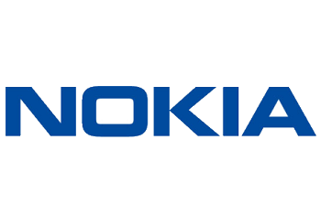

Nokia has been around the block a few times. We’ve all owned one of its basic, ‘brick’ design mobiles at some point, and while these phones may seem a bit antiquated now, they’re still virtually indestructible – and perfect for a quick game of Snake while waiting for the bus. Despite iPhones and Galaxys hogging the plaudits more recently, Nokia’s brand is still ticking away. It's currently valued in the region of a whopping 10 billion USD – and Nokia stock is poised to make an [**unexpected comeback in 2021**](https://www.nasdaq.com/articles/nokia-stock-remains-a-deep-value-investors-delight-2020-11-06). So, what’s its secret? CRM, of course!

**Nokia CRM: Case Study**

Nokia implemented Salesforce to help manage the size and diversity of its client base. Salesforce allows Nokia to customise its product range and marketing to suit geo-specific locations.

Nokia’s collaboration with CRM brought order to chaos, empowering marketing departments across countries and languages to organise customer data. Through the selecting and segmenting of data into specific target groups, Nokia’s team saw more effective lead generation – which probably helps explain why its brand is still thriving.

**6. McDonald's**



Every day, McDonald’s serves almost four million customers in the UK alone – about the population of New Zealand. Worldwide, that figure’s more like 69 million – roughly the size of Great Britain’s own populace. So, with such a vast empire and *super-sized* customer database, how does this fast food giant ensure their customers keep *lovin’ it?*With an industry-leading CRM strategy, that’s how.

**McDonald's CRM: Case Study**

McDonald’s partners with [Astute Solutions](https://www.astutesolutions.com/customers/mcdonalds#:~:text=Astute%20Agent%20allows%20McDonald's%20to,restaurants%20nationwide%20and%20in%20Canada.), allowing the restaurant chain greater insights into consumer feedback and satisfaction levels. Being able to assess restaurants by region, or even individually, means that McDonald's can quickly spot potential customer relationship issues, and resolve them before they become a serious problem.

And, with Astute Solutions, McDonald’s can also:

* Provide both its franchisees and corporate managers with live access to customer information
* Integrate data from its dynamic network of restaurants into an effective CRM tool
* Increase the accuracy of its reporting, and inform more intelligent decision-making

As Christopher Garrity, McDonald’s’ own Senior Director of Customer Satisfaction, espouses:

“CRM [is a] critically important function for any large company. It’s clear that Astute understands the important role it plays, and meets the ever-changing needs of our prime customers through continued innovation.”

*Prime* customers… was the pun intended? We don't know.

What we *can*tell you, though, is that one too many Big Macs may leave you feeling bloated and unmanageable… but your SME’s customer database doesn’t have to be.

**7. Coca Cola CRM**

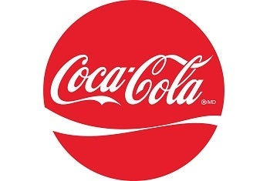

While Coca-Cola’s iconic recipe has remained a secret since 1886, this global beverage giant has been less coy about the *other*secret of its success – a dedication to the customer. It came as no surprise when Coca-Cola’s German branch adopted Salesforce – but what role did CRM software play in engineering the soft drink goliath’s continued growth?

**Coca-Cola CRM: Case Study**

*“We needed to get much faster, to work on collaboration, connectivity, and scalability — and all that in a mobile context. Salesforce has been a fantastic partner, and a great help for us.”*

That’s Coca-Cola Germany’s CEO, Ulrik Nehammer. He’s happy, because his customer service team is happy. And they’re happy because CRM software allows them instant access to customer history – which, in turn, allows them to hit their targets, and deal more efficiently with complaints.

With Salesforce, Coca-Cola Germany’s team can easily log issues with customers or suppliers, and then respond by dispatching field service technicians in real time. The result? A sweet [30% increase in productivity](https://www.salesforce.com/ap/customer-success-stories/coca-cola/). Refreshing!

**8. Unilever CRM**

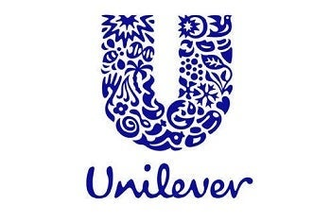

Also known as Europe’s seventh most valuable company, Unilever’s products are available in almost 200 countries around the world. With brands like Lipton, Magnum, and Hellmann’s under its considerable belt, Unilever has its fingers in a lot of pies. But does it have its finger on the pulse when it comes to managing its customer relationships?

**Unilever CRM: Case Study**

If you guessed yes, then you’re absolutely right. With the help of [SAP CRM](https://www.sap.com/uk/products/crm.html), Unilever improved its call centre capabilities, and boosted the productivity of its consumer advisory representatives. Just ask one of its head honchos:

*“[CRM] enables faster response time to queries and needs raised by consumers. It provides for effective maintenance of our customer database, and allows for easy access to customer information for analysis and strategy development.”*

* Efren Samonte, Commercial Director – Unilever Philippines

And let’s face it, the proof of Unilever CRM’s effectiveness is, quite literally, in the pudding. Because if you’ve ever scoffed down a Magnum on a hot summer’s day, then you’ve witnessed first-hand the effectiveness of Unilever’s ability to keep customers coming back. Can you emulate them?

Hopefully! But to do so, you’ll need your own CRM first. While there are some [free options](https://www.expertmarket.co.uk/crm-systems/best-free-crm-software) you can go with, these are limited, not scalable, and certainly not fit for ambitious businesses.

**9. Zara CRM**



Leading European clothing brand Zara specialises in fast fashion at low(ish) prices, and the profits are also moving quickly – it made almost 19 billion USD last year. But is it the price point that keeps Zara’s customers coming back, or its relentless, CRM strategy-powered focus on the customer? We think the latter.

**Zara CRM: Case Study**

Zara was one of the first to pioneer the use of personal digital assistants (PDAs) to capture customer data in real time – not just on transactions, but on their customer’s preferences and habits. CRM software comes in when it’s time to use this data to sell, sell, sell, re-engaging existing buyers with fresh discounts and campaigns.

**10. BMW CRM**

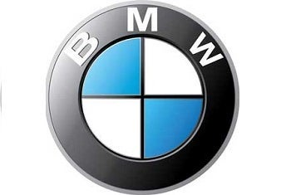

Unless you’ve been living in a cave for the last hundred years, you’ll instantly recognise BMW’s iconic logo. Producing well over two million vehicles per year, and with its [status as a film icon](https://www.bmw-m.com/en/topics/magazine-article-pool/oscars-2018-bmw-m-in-the-movies.html) firmly cemented, BMW’s success shows no signs of slowing down. And though the cars may have changed a bit since the company was founded in 1916, its customer focus has remained just the same.

**BMW CRM: Case Study**

And again, a successful CRM strategy underpins it all. To execute it, BMW teamed up with [Legacy Lifestyle](https://www.legacylifestyle.co.za/) to create a luxury loyalty scheme called – wait for it – ‘The Owner’s Circle’.

**The Owner’s Circle** lets BMW owners track their car’s financing and maintenance. Owners of new or old BMWs can also register their vehicles online. From here, they can check the status of a new car order, view the maintenance history of a used car, or get reminders about upcoming service milestones. There’s also an owner-to-owner chat box thrown in, for ultimate convenience.

All this serves to strengthen the post-purchase relationship between BMW and its customers, ensuring an enduring connection long after they’ve rolled their car out of the garage.

And, because any points earned through the Owner’s Circle can be used on a variety of luxury items, it strengthens BMW’s status as a luxury brand – and ensures it’ll be continuing to attract a lucrative clientele for many more years to come.

**11. Amazon CRM**

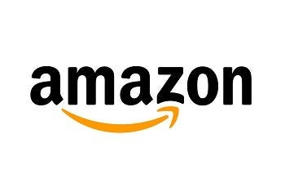

We could spend all day throwing statistics demonstrating [Amazon’s popularity](https://www.oberlo.co.uk/blog/amazon-statistics) around, but let’s face it – we’re all familiar with Amazon. As the world’s leading online retailer, Amazon continues to go from strength to strength, led by its enigmatic founder and CEO Jeff Bezos. But how have Bezos and the gang been so good at winning, retaining, and consolidating users of their wildly popular online platform?

**Amazon CRM: Case Study**

By using CRM, that’s how. And if you’ve ever used Amazon (and the data says you probably have), you’ll know how hard its tailored offers, recommendations, and promotions – all based on your past purchases – can be to resist.

Plus, by asking its customers to register for an account, Amazon makes it extremely easy for customers to re-order. Cash-rich, time-poor consumers can pay with a click, and have their goods gracing their doorstep within 24 hours.

**Next steps**

We’ve said it before, and we’ll say it again – customers are the most important part of your business. Without them, you wouldn’t have one!

With that in mind, then, ensuring you have at least some kind of **CRM strategy** is crucial. How will you draw in new leads, juggle unfolding deals, and manage prospects and client relationships? How will you keep your customers engaged, ensuring they continue to use your services while identifying with your brand and values?

If these **big brand CRM case studies** have shown us anything, it’s that CRM software is just as important as the strategic side – all of the big companies are using it to manage customer data, and extract key insights which can help improve customer experience.

*******************************************************************************